Experiments – Moment of Inertia for the Table Sat

Abstract:
Calculating the moment of inertia for a rotating disk body can be designed as a pendulum system. By suspending from four points equidistant the TSAT can be thought of as a pendulum.

What you need:

- String Stopwatch
- 4 - I Hooks 2 People

Procedure:

- Mass the TSAT setup either with a scale or with an estimation program.(ie Pro Engineer)
- Measure the distance from the center of the disk to each of the strings.
- Make sure when hanging TSAT that it is level with the ground.
- Measure the length of all the strings.
- Select a zero point on the TSAT. (A zero point is a location on the TSAT while it is at rest)
- Rotate the TSAT about 10deg release and start stop watch. Count the number of times it takes for the TSAT to pass the zero point 10 times.
- Repeat step 5 - 3 additional times recording the time needed each time to reach 10 counts.
- Remeasure the length of the string as well as the radiuses.

Analysis:

- Take all to the different lengths, radii, and times and average them together.
- Compute the time constant of the TSAT.
- Using the below equation it is possible to calculate the moment of inertia for the TSAT setup.
- Compare this value to the value found using an estimation tool. (ie Pro Engineer)

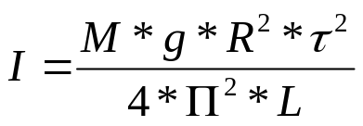

M = Mass of TSAT
g = Gravity
R = Radius from center of TSAT to strings
T = Time Constant of TSAT
L = Length of strings TSAT is hung from
Equations to find above:

Dynamic Equation for Torsional Pendulum

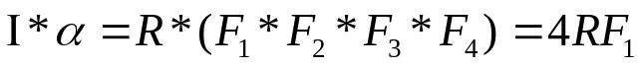

Force as a Relation to the angle of the string (beta) to the TSAT disk
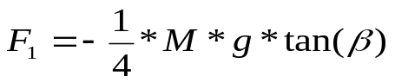

Displacement of the String relative to its zero point
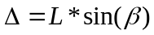
Or
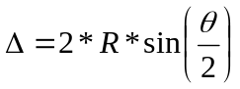

Combination of above delta equations solving for beta
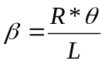

Combining above Eq with the Force equation yields
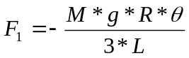

Then combining eq with the first equation yields
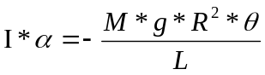

The period of the second order system
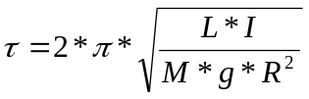

Then solving for I yields the above equation

Note all above equations are base off of the assumption that the hanging TSAT will act as a torsional pendulum.
Results

First attempt
Performed: 7/22/08

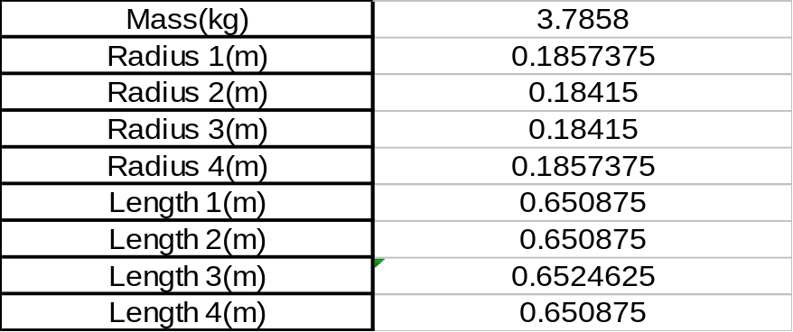
Table 1 - Initial Setup Measurements

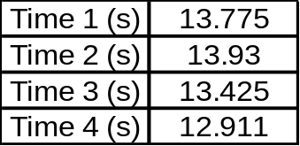
Table 2 - Time taken to pass zero point 10 times

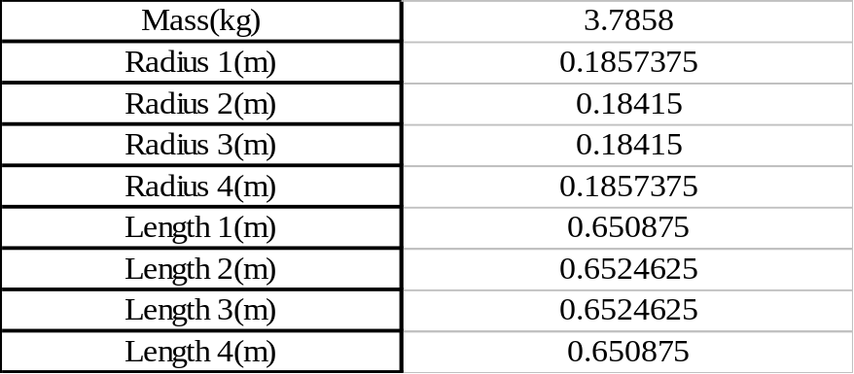
Table 3 - Measurements after inertial trials

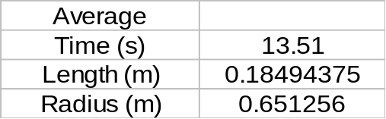
Table 4 - Averages Values

Period: 1.351seconds

Inertia: .087 kg m^2

Percent Difference: 45.7%
Second attempt
Performed: 8/6/08

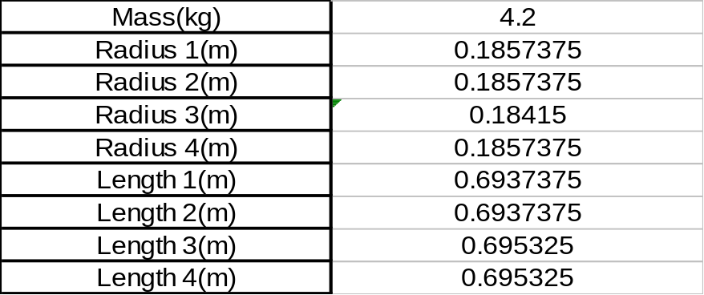
Table 5 - Initial Setup Measurements

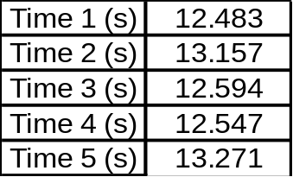
Table 6 - Time taken to pass zero point 10 times

Table 7 - Measurements after inertial trials

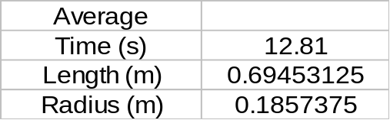
Table 8 - Averages Values

Period: 1.281 seconds

Inertia: .082 kg m^2

Theoretical: .1603 kg m^2

Percent Difference: 48.84 %

